Group Assessment Contribution Form

Course: Computing Technology Innovation Project
Project/Assignment Title: The TruthGuard Website
Group Number: HCMC2_4

1. Group Members:
Please list down all members of the group, including yourself:
- Name: Truong Ngoc Gia Hieu - Student ID:: SWS01217
- Name:Pham Dinh Duc Anh - Student ID: SWS01484
- Name: Duong Nguyen Dang - Student ID: SWS01389
- Name: Pahan Pathirathna - Student ID: SWS01652

2.Team Task & Contribution Log
To be completed and signed by all group members. This section documents the specific tasks each member was responsible for and provides evidence of their work. All members must reach a consensus on the described contributions
Group Member | Tasks
Truong Ngoc Gia Hieu | ● Lead Backend: Architected the central Brain.py logic and Joblib persistence system.  ● Provided cross-functional support for Frontend integration and final system debugging.  ● Project Monitor: Oversaw project milestones and technical integration.
Pham Dinh Duc Anh | ● Backend Engineer: Managed and preprocessed Datasets 01–26 for high-scale training.  ● Implemented the LinearSVC algorithms for Spam and Malware modules.  ● Performed technical validation using Test04.csv and Test05.csv.
Duong Nguyen Dang | ● Frontend & Analysis: Developed the user-facing output logic and Newspaper Detection analysis.  ● Lead Visualization: Generated and interpreted all Cluster Maps and Confusion Matrices for the report.  ● Supported Backend team in testing URL structure edge cases.
Pahan Pathirathna | ● Frontend & Documentation: Designed the project README.md and the E-M-B-T logical framework.  ● Report Architect: Authored the Project Abstraction, Methodology sections, and final Conclusion.  ● Coordinated group meetings and finalized the visual formatting of the submission.

3. Team Member Contributions:
As a group, discuss and evaluate the contributions of each team member in the table below. The final evaluations must represent a consensus agreed upon by the entire team.
Group Member | Contribution (100% in total) | Quality of Work ( 1-5 ) | Quality of Work ( 1-5 ) | Collaboration  ( 1-5 )
Truong Ngoc Gia Hieu | 100% | 5 | 5 | 5
Pham Dinh Duc Anh | 100% | 5 | 5 | 5
Duong Nguyen Dang | 100% | 5 | 5 | 5
Pahan Pathirathna | 100% | 5 | 5 | 5

Contribution and Grading Policy:
- Normal Grade: Members contributing 33% or more will receive the full project mark.
- Penalty: Members contributing less than 33% will incur a penalty. Their grade will be calculated as follows:
  - (Contribution Percentage/33)×Group Mark
Example: If the total group mark is 15, and a member contributes 20%, their grade will be (20/33)×15 = 9
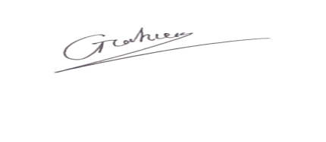
Hieu’s Signature:
Duc Anh’s Signature: 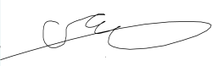
Dang’s Signature:: 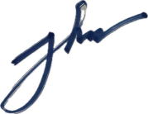
Pahan’s Signature:: 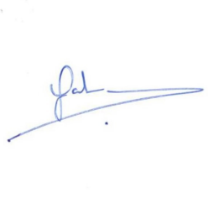
Date: 15th March, 2026

